Date: 03.01.2025
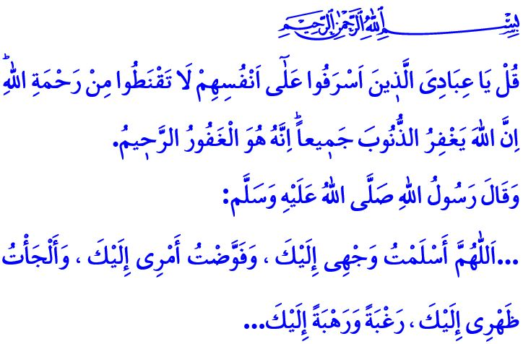The Life of a Believer Has No Place for Hopelessness
Dear Muslims!
Hope is one of the emotions that our Almighty Lord (swt) has instilled within our nature. Hope is to seek refuge in Allah the Almighty (swt) with complete surrender, placing full trust in His help and support. It is the balance of precaution with reliance on Allah (swt), patience with effort, reflecting on the past while moving forward with determination toward the future. Hope is a divine mercy that allows a person to hold on to life, strengthening his determination and fueling his efforts. It is a spiritual strength that safeguards both physical and mental health.
Hopelessness, on the other hand, erodes the joy of living. It casts a shadow over one's dreams for the future. It leads a person to laziness, distracting them from their responsibilities. Our Almighty Lord (swt) warns us in this regard as follows: “Say, ˹O Prophet, that Allah says,˺ “O My servants who have exceeded the limits against their souls! Do not lose hope in Allah’s mercy, for Allah certainly forgives all sins. He is indeed the All-Forgiving, Most Merciful.”
Dear Believers!
All the prophets sent by Allah the Almighty (swt) to humanity have never lost hope, even in the face of the most severe trials. In fact, Prophet Adam (as) sought forgiveness from Allah with hope. Prophet Nuh (as) offered advice for his son with kind words and gentle language, “O my dear son! Come aboard with us and do not be with the disbelievers.”, hoping that he would heed the guidance. Despite his severe illness, Prophet Ayyub (as) never lost faith that he would be cured, and he sought every possible means of treatment in pursuit of healing. The Messenger of Allah (saw), on the other hand, never succumbed to despair in the face of hardship, instead seeking refuge in his Lord by saying, حَسْبِيَ اللّٰهُۘ لَٓا اِلٰهَ اِلَّا هُوَۜ عَلَيْهِ تَوَكَّلْتُ وَهُوَ رَبُّ الْعَرْشِ الْعَظ۪يمِ “...Allah is sufficient for me. There is no god ˹worthy of worship˺ except Him. In Him I put my trust. And He is the Lord of the Mighty Throne.”

Dear Muslims!
We, too, may encounter difficulties from time to time. We may face challenges in our family, work, business, as well as in our relationships with neighbors and relatives. However great our troubles may be, the mercy and compassion of our Lord (swt) encompass everything. All we need is to fulfill our responsibilities towards our Lord (swt), ourselves, our family, our community, and all of humanity. All we need is to adorn our lives with righteous deeds and good character.
Esteemed Believers!
Today, the oppressors who seek to transform the world into a battlefield employ every kind of evil to destroy humanity's hopeIn many parts of the world, particularly in Palestine and Gaza, they commit mass atrocities, massacring men, women, and children alike. They even deny them basic health care and food, leaving them to perish before the eyes of the world. On the other hand, they threaten the future of families and humanity by spreading perverse ideologies that undermine reason, nature, morality, and chastity. They seek to darken the dreams and steal the hopes of the youth through alcohol, gambling, prostitution, drugs, and harmful media content. However, there is a divine decree that transcends all plans. As stated in the verse, وَمَكَرُوا وَمَكَرَ اللّٰهُۜ وَاللّٰهُ خَيْرُ الْمَاكِر۪ينَ۟ “And the disbelievers made a plan ˹against Jesus˺, but Allah also planned —and Allah is the best of planners.”
Dear Muslims!
At a time when evil is sought to spread and the hopes, ideals, and dreams for goodness are under attack, our duty is to never allow despair to take root in our lives. It is to seek refuge in the grace and mercy of our Almighty Lord (swt), after utilizing all the means at our disposal. It is to offer every possible support to our children and youth in realizing their dreams and ideals for the future. It is to extend a hand of compassion and mercy to our brothers and sisters who are mired in sin and haram, enslaved by harmful habits such as alcohol, gambling, prostitution, and substance addiction, and to make greater efforts to help them escape this plight.
I would like to conclude this Friday's khutbah with our Prophet's (saw) following supplication: “…O Allah! I have turned myself to You, committed my affairs to You and sought Your refuge for protection out of desire for You and fear of You...”

Zumar, 39/53.
Hud, 11/42.
Tawbah, 9/129.
Ali 'Imran 3/54.
Bukhari, Wudu', 75. General Directorate of Religious Services

